
SESSION: 2022-2024
: Reena
: AY1299027010
: 9027

ACADEMY OF COMPUTER SCIENCE AND TECHNOLOGY, Jabalpur

“Digital Gadgets (E-Commerce)”

Live Link: https://cibadress.com/app/msc6sem/digital_gadgets

Master of Science (CS)

Priyanka Singh Bhadauriya
(Internal Guide)

ACADEMY OF COMPUTER SCIENCE AND TECHNOLOGY,
Jabalpur (M.P.)



PROJECT CERTIFICATE

This is to certify that the project report entitled Digital Gadgets (E-Commerce) submitted to MakhanlalChaturvedi National University of Journalism & Communication, in partial fulfillment of the requirement for the award of the degree of Master of Science (CS), is original work carried out by myself Ms. Reena with enrolment no.AY1299027010 under the Supervision of Miss. Priyanka Singh Bhadauriya.The matter embodied in this project is genuine work done by myself and has not been submitted whether to this University or to any other University / Institute for the fulfillment of the requirement of any course of study.

Date:………………

Student’s Signature______________
Student Name: Reena
Email:________________________
Mobile:
Address:

Signature of the Supervisor
Miss. Priyanka Singh Bhadauriya
Date: ………………..

ACKNOWLEDGEMENT

This Major Project is the result of contribution of many minds. I would like to acknowledge and thank my project guide Miss. Priyanka Singh Bhadauriya for her valuable support andguidance. She guided me through the process from conception and till the completion of this project. I would also like to thanks my class teacher/institute director Dr. Prashant Karmveer and my all my faculties of ACST, Jabalpur. I thank to lab staff members Ms. Roopali Mam’m and other non-teaching members.

I am very thankful for the open-handed support extended by many people. While no list would be complete, it is my pleasure to acknowledge the assistance of my friends who provided encouragement, knowledge and constructive suggestions.

Signature of Student
Name: Reena
Roll no.:
Enroll No.: AY1299027010

SELF-CERTIFICATE

This is to certify that the Major Project report entitled “Digital Gadgets (E-Commerce)” is done by me, and it is authentic work carried out for the partial fulfillment of the requirements for the award of the degree of of Master of Science (CS) under the guidance of Miss. Priyanka Singh Bhadauriya. The matter and software embody in this project has not been submitted earlier for award of any degree or diploma to the best of my knowledge and believes.

Signature of Student
Name: Reena
Roll no.:
Enroll No.: AY1299027010

CERTIFICATE FROM PROJECT GUIDE

This is certify that this Major Project entitled “Digital Gadgets (E-Commerce)” submitted in partial fulfillment of the requirements for the award of the degree of of Master of Science (CS) in session (years 2022 to 2024) to the Makhanlal Chaturvedi National University of Journalism & Communication, Bhopal, done by Ms. Reena is an authentic work carried out by her at “Academy Of Computer Science And Technology, Jabalpur” under my guidance. The matter and software embodied in this project work has not been submitted earlier for the award of any degree or diploma to the best of my knowledge and belief.

Miss. Priyanka Singh Bhadauriya
(Project Guide)

INDEX

Sr. | Chapter | Page No.
1. | Introduction to project | 07
2. | Feasibility Study | 08-09
3. | Hardware & Software Requirement | 10
4. | Development Tools Specification | 11-13
5. | Frontend & Backend Technology | 14
6. | Directory Structure | 19
7. | Database Design | 20-23
8. | Coding | 24-36
9. | System Flow Diagram | 37
10. | Forms | 38-41
11. | Bibliography | 42

Introduction to the project

Our project “DIGITAL GADGETS” is an e-commerce website is one that allows people to buy and sell physical goods, services, and digital products over the internet rather than at a brick-and-mortar location. Through an e-commerce website, a business can process orders, accept payments, manage shipping and logistics, and provide customer service.
It’s tough to imagine daily life without e-commerce. We order food, clothes, and furniture; we register for classes and other online services; we download books, music, and movies; and so much more. E-commerce has taken root and is here to stay.

This project includes following modules:

Domian
Hosting
Authorization
Publishing a Post
Recent Product
Admin Center
Product Management
Category Management
User Management
Site Setting Management
Searching
Cart
Order conformation

Feasibility study

Launching an e-commerce website involves a multifaceted feasibility study, encompassing market analysis, technical requirements, financial projections, and risk assessment. First, the market analysis aims to identify the target audience, understand customer needs, and evaluate the competition. This involves examining market trends, customer behavior, and the competitive landscape to ensure there is a viable demand for the products or services offered. Tools such as SWOT analysis (Strengths, Weaknesses, Opportunities, Threats) can be instrumental in identifying the strategic positioning of the new e-commerce venture.
From a technical standpoint, the feasibility study assesses the necessary infrastructure, including website design, hosting solutions, security measures, and integration with payment gateways. The technical feasibility must ensure that the website will offer a seamless user experience, robust performance, and high security to protect customer data. This involves detailed planning of the website architecture, user interface design, backend systems, and compliance with legal and industry standards, such as GDPR for data protection.

Technical feasibility
The Proposed system is developed by Server Language PHP 5.5 [XAMPP server]
Language Used
  - Front End (User Interface) HTML 5, CSS, JAVASCRIPT, BOOTSTRAP
  - Server Language PHP 8.0.1
  - Backend MYSQL

Economical feasibility
Evaluating economic feasibility also involves considering external economic factors, such as market trends and consumer purchasing power, which can impact the business's financial outlook. Ultimately, thorough economic analysis ensures that the e-commerce venture is financially sustainable and capable of generating profit.
Operational feasibility
. Logistics and Supply Chain:
- Inventory Management: Systems for stock monitoring and replenishment.
- Shipping and Delivery: Partnerships with reliable courier services.
- Returns and Refunds: Clear policies and efficient processing systems.

PROJECT PLANNING & SCHEDULE

System Actors (Users)
- Admin
- Registered Users
- Guest Users

Admin Features
- Admin Login
- Admin can Add New Product Details
- Admin can Manage Product Details (Edit, Delete)
- Admin can Add New Category Details
- Admin Can Manage Category Details (Edit, Delete)
- Admin can Add New User Details
- Admin Can Manage User Details (Edit, Delete)
- Admin Can Check All registered users’ details
- Admin can update other page content Like Website Logo & Name, Website Footer.
- Admin Dashboard has (List of all Product, List of all Category, List of all users, Website Settings Tab)
Registered User Features
- New User can Registered by Admin User.
- Registered User can login with valid username and password
- User Can Recover Forget password through Administration
- User can find Post details and get useful information
- User can View Product Publish date
- User Can Update their Username
- User Can Update their Password
- Logout

Guest User Features
- Guest user can view the website and Surfe/Find Post details
There should be a Web App version for the software to connect with for those who wish for a quick DIGITAL GADGETS servicer. The Web App will be responsive to any device using it.This allows for learner to access the service from any sort of hardware device: tablet, computer, mobile devices, and so on. The software itself will be available on all computer platforms that are running any aspect of Linux, Windows 7, Windows 8, and Mac operating systems.

Hardware & Software Requirement

HARDWARE

Processor | x86 or x64
Ram | 512 MB (minimum) or above
Hard Disk Space | 512 MB or Above
Floppy Disk Drive | 1.44 Mb
Server-Side Scripting Language | PHP 5.3.3+ version
Server | Apache Server
Monitor | Which can support resolution of 800x600 pixels or more
Keyboard & Mouse | Dell
Lan Card | For network

SOFTWARE

Operating System | Windows 10
Database | MySQL
Development Tool | - Visual Studio Code Editor  XAMPP
Browser | - Google Chrome

Development tools specification

Windows 10 (Operating System)

Microsoft Windows is a GUI (Graphical User Interface) multitasking operating system, that is in its environment user can perform a lot of job in a very short span of time where as in case of other environments this it is not possible. If a user has to work with more then one software, then one or the other must be closed so that another can be taken into use. Along with this due to the GUI nature of WINDOWS user need not to look for each and every command that has to be supplied to the machine each and every thing is available to the user in front of its eyes in form of big/small picture or text material.
Welcome to Windows 10 Professional. Among the new features available in Windows 10, there are new security tools that you can use to help keep your computer more secure, and new technologies that run in the background, making your computer run more efficiently and reliably.
Windows 10 has improved upon security, including the new Security Center, which allows you to check the status of the important security elements on your computer—Windows Firewall, Automatic Updates, and virus protection software—making it easier for you to understand how to keep your computer better protected against viruses and other security threats. Performance is at an all-time high. You can now use more programs at the same time and they will run faster than ever. Windows 10 is dependable and stable, so you can always rely on the performance and effectiveness of your computer.
Improvements have also been made on many features that make using your computer more effective and useful. For example, you can use Remote Desktop to access your work computer and its resources from home, and to view files and documents on your computer's desktop from a co-worker's computer. With NetMeeting you can have virtual meetings with anyone, anywhere, and you can participate in discussions using audio, video, or chat. Getting help has never been easier. With Remote Assistance, you just send an invitation (either in e-mail or Instant Messenger) to your favorite computer expert or support professional, and they can help you fix a problem from their location. Windows 10 provides extensive online Help for all operating system features, as well as a digital tour to help you discover the possibilities awaiting you.

XAMPP SERVER

XAMPP is one of the widely used cross-platform web servers, which helps developers to create and test their programs on a local webserver. It was developed by the Apache Friends, and its native source code can be revised or modified by the audience. It consists of Apache HTTP Server, MariaDB, and interpreter for the different programming languages like PHP and Perl. It is available in 11 languages and supported by different platforms such as the IA-32 package of Windows & x64 package of macOS and Linux.

What is XAMPP?
XAMPP is an abbreviation where X stands for Cross-Platform, A stands for Apache, M stands for MYSQL, and the Ps stand for PHP and Perl, respectively. It is an open-source package of web solutions that includes Apache distribution for many servers and command-line executables along with modules such as Apache server, MariaDB, PHP, and Perl.
XAMPP helps a local host or server to test its website and clients via computers and laptops before releasing it to the main server. It is a platform that furnishes a suitable environment to test and verify the working of projects based on Apache, Perl, MySQL database, and PHP through the system of the host itself. Among these technologies, Perl is a programming language used for web development, PHP is a backend scripting language, and MariaDB is the most vividly used database developed by MySQL. The detailed description of these components is given below.

Components of XAMPP
As defined earlier, XAMPP is used to symbolize the classification of solutions for different technologies. It provides a base for testing of projects based on different technologies through a personal server. XAMPP is an abbreviated form of each alphabet representing each of its major components. This collection of software contains a web server named Apache, a database management system named MariaDB and scripting/ programming languages such as PHP and Perl. X denotes Cross-platform, which means that it can work on different platforms such as Windows, Linux, and macOS. Many other components are also part of this collection of software and are explained below.
- Cross-Platform: Different local systems have different configurations of operating systems installed in it. The component of cross-platform has been included to increase the utility and audience for this package of Apache distributions. It supports various platforms such as packages of Windows, Linus, and MAC OS.
- Apache: It is an HTTP a cross-platform web server. It is used worldwide for delivering web content. The server application has made free for installation and used for the community of developers under the aegis of Apache Software Foundation. The remote server of Apache delivers the requested files, images, and other documents to the user.
- MariaDB: Originally, MySQL DBMS was a part of XAMPP, but now it has been replaced by MariaDB. It is one of the most widely used relational DBMS, developed by MySQL. It offers online services of data storage, manipulation, retrieval, arrangement, and deletion.
- PHP: It is the backend scripting language primarily used for web development. PHP allows users to create dynamic websites and applications. It can be installed on every platform and supports a variety of database management systems. It was implemented using C language. PHP stands for Hypertext Processor. It is said to be derived from Personal Home Page tools, which explains its simplicity and functionality.
- Perl: It is a combination of two high-level dynamic languages, namely Perl 5 and Perl 6. Perl can be applied for finding solutions for problems based on system administration, web development, and networking. Perl allows its users to program dynamic web applications. It is very flexible and robust.
- phpMyAdmin: It is a tool used for dealing with MariaDB. Its version 4.0.4 is currently being used in XAMPP. Administration of DBMS is its main role.
- OpenSSL: It is the open-source implementation of the Secure Socket Layer Protocol and Transport Layer Protocol. Presently version 0.9.8 is a part of XAMPP.
- XAMPP Control Panel: It is a panel that helps to operate and regulate upon other components of the XAMPP. Version 3.2.1 is the most recent update. A detailed description of the control panel will be done in the next section of the tutorial.
- Webalizer: It is a Web Analytics software solution used for User logs and provide details about the usage.
- Mercury: It is a mail transport system, and its latest version is 4.62. It is a mail server, which helps to manage the mails across the web.
- Tomcat: Version 7.0.42 is currently being used in XAMPP. It is a servlet based on JAVA to provide JAVA functionalities.

VISUAL STUDIO CODE

Visual Studio Code is a code editor in layman’s terms. Visual Studio Code is “a free-editor that helps the programmer write code, helps in debugging and corrects the code using the intelli-sense method”. In normal terms, it facilitates users to write the code in an easy manner. Many people say that it is half of an IDE and an editor, but the decision is up to to the coders. Any program/software that we see or use works on the code that runs in the background. Traditionally coding was used to do in the traditional editors or even in the basic editors like notepad! These editors used to provide basic support to the coders.
Some of them were so basic that it was very difficult in writing basic English level programs in them. As time went by, some programming languages needed a specific framework and support for further coding and development it, which was not possible using these editors. VI Editor, Sublime Text Editor, is one of the many kinds of editors that came into existence. The most prominent and which supports almost every coding language is VISUAL STUDIO CODE. Its features let the user modify the editor as per the usage, which means the user is able to download the libraries from the internet and integrate it with the code as per his requirements.
Visual Studio Code has some very unique features. They are listed as below :
- Support for multiple programming languages: Supports multiple programming languages. So earlier, programmers needed Web-Support: a different editor for different languages, but it has built-in multi-language support. This also means it easily detects if there’s any fault or cross-language reference, it’ll be able to detect it easily.
- Intelli-Sense: It can detect if any snippet of code is left incomplete. Also, common variable syntaxes and variable declarations are made automatically. Ex: If a certain variable is being used in the program and the user has forgotten to declare, intelli-sense will declare it for the user.

Introduction to PHP

What is a PHP File?
- PHP files can contain text, HTML, CSS, JavaScript, and PHP code
- PHP code is executed on the server, and the result is returned to the browser as plain HTML
- PHP files have extension ".php"

What Can PHP Do?
- PHP can generate dynamic page content
- PHP can create, open, read, write, delete, and close files on the server
- PHP can collect form data
- PHP can send and receive cookies
- PHP can add, delete, modify data in your database
- PHP can be used to control user-access
- PHP can encrypt data
With PHP you are not limited to output HTML. You can output images or PDF files. You can also output any text, such as XHTML and XML.

Why PHP?
- PHP runs on various platforms (Windows, Linux, Unix, Mac OS X, etc.)
- PHP is compatible with almost all servers used today (Apache, IIS, etc.)
- PHP supports a wide range of databases
- PHP is free. Download it from the official PHP resource: www.php.net
- PHP is easy to learn and runs efficiently on the server side

What's new in PHP 7

PHP 7 is much faster than the previous popular stable release (PHP 5.6)

PHP 7 has improved Error Handling

PHP 7 supports stricter Type Declarations for function arguments

PHP 7 supports new operators (like the spaceship operator: <=>)
osts offer PHP support.

Set Up PHP on Your Own PC
However, if your server does not support PHP, you must:
- install a web server
- install PHP
- install a database, such as MySQL
The official PHP website (PHP.net) has installation instructions for PHP: http://php.net/manual/en/install.php

Introduction to HTML
HTML is an acronym which stands for Hyper Text Markup Language which is used for creating web pages and web applications. Let's see what is meant by Hypertext Markup Language, and Web page.
Hyper Text: HyperText simply means "Text within Text." A text has a link within it, is a hypertext. Whenever you click on a link which brings you to a new webpage, you have clicked on a hypertext. HyperText is a way to link two or more web pages (HTML documents) with each other.
Markup language: A markup language is a computer language that is used to apply layout and formatting conventions to a text document. Markup language makes text more interactive and dynamic. It can turn text into images, tables, links, etc.
Web Page: A web page is a document which is commonly written in HTML and translated by a web browser. A web page can be identified by entering an URL. A Web page can be of the static or dynamic type. With the help of HTML only, we can create static web pages.
Hence, HTML is a markup language which is used for creating attractive web pages with the help of styling, and which looks in a nice format on a web browser. An HTML document is made of many HTML tags and each HTML tag contains different content.
Let's see a simple example of HTML.

<!DOCTYPE>
<html>
<head>
<title>Web page title</title>
</head>
<body>
<h1>Write Your First Heading</h1>
<p>Write Your First Paragraph.</p>
</body>
</html>

Introduction to CSS

What is CSS
CSS stands for Cascading Style Sheets. It is a style sheet language which is used to describe the look and formatting of a document written in markup language. It provides an additional feature to HTML. It is generally used with HTML to change the style of web pages and user interfaces. It can also be used with any kind of XML documents including plain XML, SVG and XUL.
CSS is used along with HTML and JavaScript in most websites to create user interfaces for web applications and user interfaces for many mobile applications.

What does CSS do
- You can add new looks to your old HTML documents.
- You can completely change the look of your website with only a few changes in CSS code.

Why use CSS
These are the three major benefits of CSS:

1) Solves a big problem
Before CSS, tags like font, color, background style, element alignments, border and size had to be repeated on every web page. This was a very long process. For example: If you are developing a large website where fonts and color information are added on every single page, it will be become a long and expensive process. CSS was created to solve this problem. It was a W3C recommendation.

2) Saves a lot of time
CSS style definitions are saved in external CSS files so it is possible to change the entire website by changing just one file.

3) Provide more attributes
CSS provides more detailed attributes than plain HTML to define the look and feel of the website.

Introduction to JAVASCRIPT

JavaScript is a lightweight, cross-platform, and interpreted compiled programming language which is also known as the scripting language for webpages. It is well-known for the development of web pages, many non-browser environments also use it. JavaScript can be used for Client-side developments as well as Server-side developments. Javascript is both imperative and declarative type of language. JavaScript contains a standard library of objects, like Array, Date, and Math, and a core set of language elements like operators, control structures, and statements.

Client-side: It supplies objects to control a browser and its Document Object Model (DOM). Like if client-side extensions allow an application to place elements on an HTML form and respond to user events such as mouse clicks, form input, and page navigation. Useful libraries for the client-side are AngularJS, ReactJS, VueJS and so many others.
Server-side: It supplies objects relevant to running JavaScript on a server. Like if the server-side extensions allow an application to communicate with a database, and provide continuity of information from one invocation to another of the application, or perform file manipulations on a server. The useful framework which is the most famous these days is node.js.
Imperative language – In this type of language we are mostly concern about how it is to be done . It simply control the flow of computation . The procedural programming approach , object, oriented approach comes under this like async await we are thinking what it is to be done further after async call.

Declarative programming – In this type of language we are concern about how it is to be done , basically here logical computation require . Here main goal is to describe the desired result without direct dictation on how to get it like arrow function do .
JavaScript can be added to your HTML file in two ways:
Internal JS: We can add JavaScript directly to our HTML file by writing the code inside the <script> tag. The <script> tag can either be placed inside the <head> or the <body> tag according to the requirement.

External JS: We can write JavaScript code in other file having an extension.js and then link this file inside the <head> tag of the HTML file in which we want to add this code.

Introduction To MySQL DBMS

Back End Tool

A back end is software which stores the data, manages it properly as it is designed by the user/programmer. One can store, retrieve, update or delete the data when ever needed or required. Not only can this it also retrieve the data when ever needed and as needed.

A back end tool can be a DBMS (Data Base Management System) or RDBMS (Relational Data Base Management System). A DBMS is software which allows the user to read, write and manipulate the data from the front end but it cannot allow the flexibility of establishing relations between the different tables of the back end. On establishing relations it becomes easy for the user to make regular checks for the availability of the records/values required according to the need.

An RDBMS allows storing and manipulating the data in the same manner as what a DBMS allows along with which it also gives the flexibility of establishing relations in between two or more tables on the basis of values stored in them.

Microsoft Access is a powerful program to create and manage your databases. It has many built in features to assist you in constructing and viewing your information. Access is much more involved and is a more genuine database application than other programs such as Microsoft Works.

- First of all you need to understand how Microsoft Access breaks down a database. Some keywords involved in this process are: Database File, Table, Record, Field, Data-type. Here is the Hierarchy that SQL Server uses in breaking down a database.
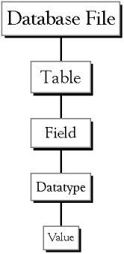 | Database File: This is your main file that encompasses the entire database and that is saved to your hard-drive or floppy disk.  Example) StudentDatabase.mdb
Table:A table is a collection of data about a specific topic. There can be multiple tables in a database.
Example #1) Students
Example #2) Teachers
Field:Fields are the different categories within a Table. Tables usually contain multiple fields.
Example #1) Student LastName
Example #2) Student FirstName
Datatypes:Datatypes are the properties of each field. A field only has 1 datatype.
FieldName) Student LastName
Datatype) Text

Directory Structure
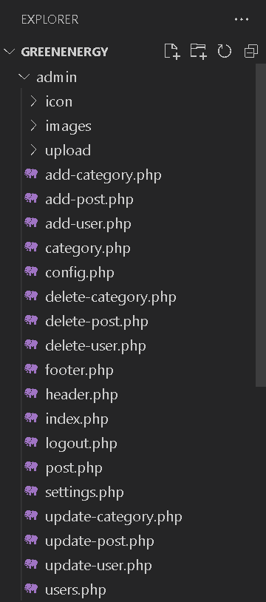
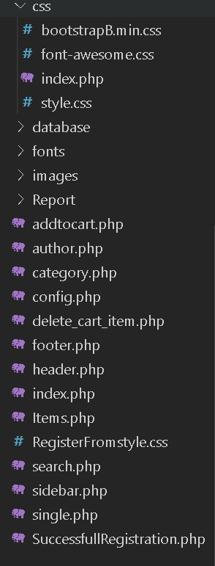

Database Design

Table Name: category

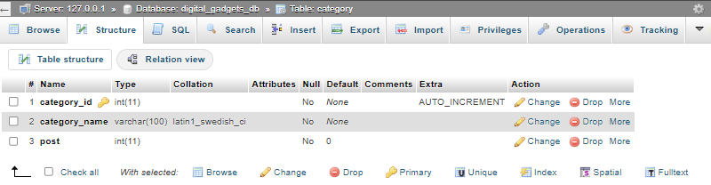

Table Name: post

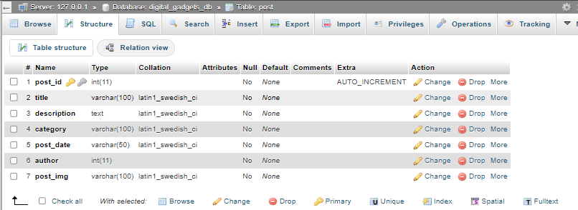

Table Name: user

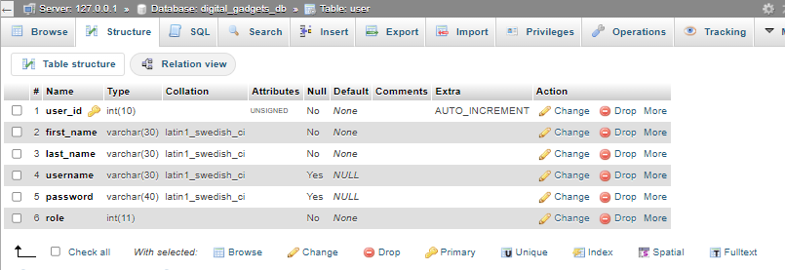

Table Name: settings

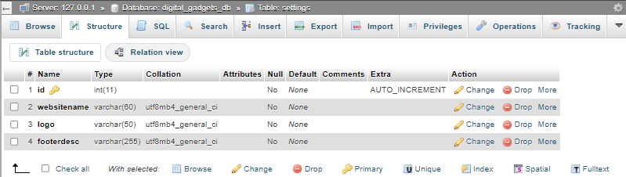

Table Name: cart

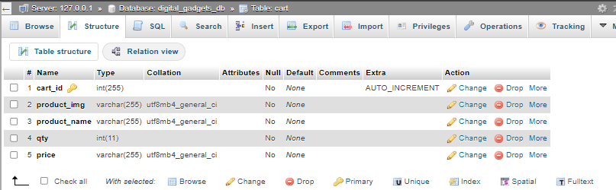

Entity-Relationship Model

post_id
title
description
category
postdate
author Directory Str
post_img
category _id
category_name
post
id
websitename
logo
footerdesc
username
password
role
last_name
first_name
user_id
category id

User id
cart_id
product_img
product_name
qty
price
cart_id

POST

category

settings

user
cart

Coding

admin/add-post.php

<?php include("header.php");include("config.php");if(isset($_POST['submit'])){session_start();if(isset($_FILES['fileToUpload'])){$file_name=$_FILES['fileToUpload']["name"];$file_tmp=$_FILES['fileToUpload']["tmp_name"];$file_type=$_FILES['fileToUpload']["type"];$file_size=$_FILES['fileToUpload']["size"];$file_ext=strtolower(end(explode('.',$file_name)));$allow_extension=array("jpg","jpeg","png");$file_error=array();if(in_array($file_ext,$allow_extension)===false){$file_error[]="This extension file not allowed, Please choose a JPG or PNG file.";}if($file_size>2097152){$file_error[]="Image must be 2mb or lower.";}$save_img_name=date("d_M_Y_h_i_sa")."_".basename($file_name);$img_save_target="upload/";if(empty($file_error)==true){move_uploaded_file($file_tmp,$img_save_target.$save_img_name);}else{print_r($file_error);die();}}$post_title=mysqli_real_escape_string($conn,$_POST['post_title']);$post_decs=mysqli_real_escape_string($conn,$_POST['postdesc']);$post_cate=mysqli_real_escape_string($conn,$_POST['category']);$post_date=date("d M, Y");$post_author=$_SESSION['user_id'];$sql_insert_post="INSERT INTO post (title,description,category,post_date,author,post_img)
VALUES ('{$post_title}','{$post_decs}','{$post_cate}','{$post_date}','{$post_author}','{$save_img_name}');";$sql_insert_post.="UPDATE category SET post = post + 1 WHERE category_id = '{$post_cate}'";if(mysqli_multi_query($conn,$sql_insert_post)){header("Location:{$hostname}/admin/post.php");}else{echo "<div class='alert alert-danger'>Post Not Submit</div>";}} ?><div id="admin-content"><div class="container"><div class="row"><div class="col-md-12"><h1 class="admin-heading">Add New Post</h1></div><div class="col-md-6 col-md-offset-3"><form action="<?php $_SERVER['PHP_SELF'] ?>"enctype="multipart/form-data"method="POST"><div class="form-group"><label for="post_title">Title</label> <input name="post_title"required class="form-control"autocomplete="off"></div><div class="form-group"><label for="exampleInputPassword1">Description</label> <textarea class="form-control"name="postdesc"required rows="5"></textarea></div><div class="form-group"><label for="exampleInputPassword1">Category</label> <select class="form-control"name="category"><option disabled selected>Select Category</option><?php include("config.php");$sql_category_list="SELECT * from category"or die("Query Die!! --> sql_category_list");$result_sql_category_list=mysqli_query($conn,$sql_category_list);if(mysqli_num_rows($result_sql_category_list)>0){while($row=mysqli_fetch_assoc($result_sql_category_list)){ ?><option value="<?php echo($row['category_id']) ?>"><?php echo($row['category_name']) ?></option><?php }} ?></select></div><div class="form-group"><label for="exampleInputPassword1">Post image</label> <input name="fileToUpload"required type="file"></div><input name="submit"required class="btn btn-primary"type="submit"value="Save"></form></div></div></div></div><?php include "footer.php"; ?>

admin/add-user.php

<?php include "header.php"; ?><div id="admin-content"><div class="container"><div class="row"><div class="col-md-12"><h1 class="admin-heading">Add User</h1></div><div class="col-md-6 col-md-offset-3"><?php if(isset($_POST['save'])){include("config.php");$fname=mysqli_real_escape_string($conn,$_POST['fname']);$lname=mysqli_real_escape_string($conn,$_POST['lname']);$username=mysqli_real_escape_string($conn,$_POST['user']);$pass=mysqli_real_escape_string($conn,md5($_POST['password']));
$role=mysqli_real_escape_string($conn,$_POST['role']);
$sql_user_cheack="SELECT username FROM user WHERE username = '{$username}'";$result_user_cheack=mysqli_query($conn,$sql_user_cheack)or die("Query Die ( sql_user_cheack )!!");if(mysqli_num_rows($result_user_cheack)>0){echo("<p style='font:red;text-align:center'>User already Exsits !!</p>");}else{$sql_insert_user="INSERT INTO user (first_name, last_name,username,password,role) values('{$fname}','{$lname}','{$username}','{$pass}','{$role}')";if(mysqli_query($conn,$sql_insert_user)){header("Location:{$hostname}/admin/users.php");}}} ?><form action="<?php $_SERVER['PHP_SELF'] ?>"autocomplete="off"method="POST"><div class="form-group"><label>First Name</label> <input class="form-control"name="fname"required placeholder="First Name">
</div><div class="form-group">
<label>Last Name</label>
<input class="form-control"name="lname"required placeholder="Last Name"></div><div class="form-group"><label>
User Name</label> <input class="form-control"name="user"required placeholder="Username"></div>
<div class="form-group"><label>Password</label> <input class="form-control"name="password"required placeholder="Password"type="password"></div><div class="form-group"><label>
User Role</label> <select class="form-control"name="role">
<option value="0">Normal User</option><option value="1">Admin</option></select></div><input class="btn btn-primary"name="save"required
type="submit"value="Save">
</form></div>
</div></div></div>
<?php include "footer.php"; ?>
admin/config.php

<?php
$website_display_default_name = "Digital_Gadgets's";
$hostname = "http://localhost/DIGITAL_GADGETS";
$conn = mysqli_connect('localhost', 'root', '', 'digital_gadgets_db') or die("Connection Failed!!" . mysqli_connect_error());
?>

admin/delete-category.php

<?php
include("config.php");
$category_index_by_addbar = $_GET['category_index'];
$sql_category_delete = "DELETE FROM category WHERE category_id = {$category_index_by_addbar}" or die("Query Failed!! --> sql_category_delete");
if (mysqli_query($conn,$sql_category_delete)) { header("Location:{$hostname}/admin/category.php");}mysqli_close($conn);?>

admin/delete-post.php

<?php include("config.php");$post_id_by_addbar=$_GET['post_id'];$cate_id_by_addbar=$_GET['cate_id'];$sql_select_post_img="SELECT * FROM post WHERE post_id = {$post_id_by_addbar}";$result_sql_select_post_img=mysqli_query($conn,$sql_select_post_img)or die("Query Die !! --> sql_select_post_img");if(mysqli_num_rows($result_sql_select_post_img)>0){$row=mysqli_fetch_assoc($result_sql_select_post_img);unlink("upload/".$row['post_img']);}$sql_delete_post="DELETE FROM post WHERE post_id = {$post_id_by_addbar};";$sql_delete_post.="UPDATE category SET post = post - 1 WHERE category_id = {$cate_id_by_addbar}";if(mysqli_multi_query($conn,$sql_delete_post)){header("Location:{$hostname}/admin/post.php");}else{echo("<div class='alert alert-danger'>Can't Delete Post!!</div>");}mysqli_close($conn); ?>
admin/delete-user.php

<?php include("config.php");$user_id_getaddbar=$_GET['id'];$sql_delete_user="DELETE FROM user WHERE user_id='{$user_id_getaddbar}'";if(mysqli_query($conn,$sql_delete_user)){header("Location:{$hostname}/admin/users.php");}else{echo("<p style='color:red; margin:10px 0;'>Can't Delete the User Record.");}mysqli_close($conn); ?>

admin/footer.php

<div id="footer"><div class="container"><div class="row"><div class="col-md-12"><?php include("config.php");$sql_setting_record="SELECT * FROM settings";$result_sql_setting_record=mysqli_query($conn,$sql_setting_record)or die("Query Die !! --> sql_setting_record");if(mysqli_num_rows($result_sql_setting_record)>0){while($row_setting_record=mysqli_fetch_assoc($result_sql_setting_record)){if($row_setting_record['footerdesc']==""){echo '<span>Footer Not Found!!</span>';}else{echo '<span>'.$row_setting_record['footerdesc'].'</span>';}}} ?></div></div></div></div>

admin/header.php

<?php include("config.php");session_start();if(!isset($_SESSION['username'])){header("Location:{$hostname}/admin/");}$current_page=basename($_SERVER['PHP_SELF']);$prefix_word="ADMIN Panel";switch($current_page){case 'add-category.php':$page_title="{$prefix_word} - Category Add";break;case 'add-post.php':$page_title="{$prefix_word} - Post Add";break;case 'add-user.php':$page_title="{$prefix_word} - User Add";break;case 'category.php':$page_title="{$prefix_word} - Category";break;case 'post.php':$page_title="{$prefix_word} - Post";break;case 'settings.php':$page_title="{$prefix_word} - Settings";break;case 'update-category.php':$page_title="{$prefix_word} - Category Update";break;case 'update-post.php':$page_title="{$prefix_word} - Post Update";break;case 'update-user.php':$page_title="{$prefix_word} - User Update";break;case 'users.php':$page_title="{$prefix_word} - Users";break;default:$page_title=$website_display_default_name;break;} ?><!doctypehtml><html lang="en"><head><meta charset="UTF-8"><meta content="width=device-width,initial-scale=1"name="viewport"><meta content="ie=edge"http-equiv="X-UA-Compatible"><link href="http://Digital_Gadgetsacstproject.infinityfreeapp.com/admin/icon/graduation-cap.png"rel="shortcut icon"type="x-con"><title><?php echo($page_title); ?></title><link href="../css/bootstrap.min.css"rel="stylesheet"><link href="../css/font-awesome.css"rel="stylesheet"><link href="../css/style.css"rel="stylesheet"></head><body><div id="header-admin"><div class="container"><div class="row"><div class="col-md-2"><?php include("config.php");$sql_setting_record="SELECT * FROM settings";$result_sql_setting_record=mysqli_query($conn,$sql_setting_record)or die("Query Die !! --> sql_setting_record");if(mysqli_num_rows($result_sql_setting_record)>0){while($row_setting_record=mysqli_fetch_assoc($result_sql_setting_record)){if($row_setting_record['logo']==""){echo '<a href="index.php"><h1>'.$row_setting_record['websitename'].'</h1></a>';}else{echo('<a href="index.php" id="logo"><img src="images/'.$row_setting_record['logo'].'"></a>');}}} ?></div><div class="col-md-3 col-md-offset-7"><a href="logout.php"class="admin-logout">Hello<?php echo $_SESSION['username']; ?>, LOGOUT</a></div></div></div></div><div id="admin-menubar"><div class="container"><div class="row"><div class="col-md-12"><ul class="admin-menu"><li><a href="post.php">Post</a></li><?php if($_SESSION['user_role']==1){ ?><li><a href="category.php">Category</a></li><li><a href="users.php">Users</a></li><li><a href="settings.php">Settings</a></li><?php } ?></ul></div></div></div></div>

admin/index.php

<?php include("config.php");session_start();if(isset($_SESSION['username'])){header("Location:{$hostname}/admin/post.php");} ?><!doctypehtml><html><head><meta charset="UTF-8"><meta content="width=device-width,initial-scale=1"name="viewport"><meta content="ie=edge"http-equiv="X-UA-Compatible"><link href="http://localhost/DIGITAL_GADGETS/admin/icon/graduation-cap.png"rel="shortcut icon"type="x-con"><title>ADMIN | Login</title><link href="../css/bootstrap.min.css"rel="stylesheet"><link href="font/font-awesome-4.7.0/css/font-awesome.css"rel="stylesheet"><link href="../css/style.css"rel="stylesheet"></head><body><div class="body-content"id="wrapper-admin"><div class="container"><div class="row"><div class="col-md-4 col-md-offset-4"><?php include("config.php");$sql_setting_record="SELECT * FROM settings";$result_sql_setting_record=mysqli_query($conn,$sql_setting_record)or die("Query Die !! --> sql_setting_record");if(mysqli_num_rows($result_sql_setting_record)>0){while($row_setting_record=mysqli_fetch_assoc($result_sql_setting_record)){if($row_setting_record['logo']==""){echo '<a href="index.php"><h1>'.$row_setting_record['websitename'].'</h1></a>';}else{echo('<img class="logo" src="images/'.$row_setting_record['logo'].'">');}}} ?><h3 class="heading">Admin</h3><?php if(isset($_POST['login'])){include("config.php");$username=mysqli_real_escape_string($conn,$_POST['username']);$pass=mysqli_real_escape_string($conn,md5($_POST['password']));$sql_user_pass_cheack="SELECT * FROM user WHERE username = '{$username}' AND password = '{$pass}'"or die("Query Failed!! --> sql_user_pass_cheack");$result_sql_user_pass_cheack=mysqli_query($conn,$sql_user_pass_cheack);if(mysqli_num_rows($result_sql_user_pass_cheack)>0){while($row=mysqli_fetch_assoc($result_sql_user_pass_cheack)){session_start();$_SESSION['user_id']=$row['user_id'];$_SESSION['username']=$row['username'];$_SESSION['user_role']=$row['role'];header("Location:{$hostname}/admin/post.php");}}else{echo "<div class='alert alert-danger'>Invalid username and password!!</div>";}} ?><form action="<?php $_SERVER['PHP_SELF'] ?>"method="POST"><div class="form-group"><label>Username</label> <input class="form-control"name="username"placeholder=""required></div><div class="form-group"><label>Password</label> <input class="form-control"name="password"placeholder=""required type="password"></div><input class="btn btn-primary"name="login"type="submit"value=" login "> <button class="btn btn-secondary"><a href="http://localhost/DIGITAL_GADGETS/">Back</a></button></form></div></div></div></div></body></html>

admin/logout.php

<?php include("config.php"); session_start(); session_unset(); session_destroy();
header("Location:{$hostname}/admin/");?>

admin/post.php

<?php include "header.php"; ?><div id="admin-content"><div class="container"><div class="row"><div class="col-md-10"><h1 class="admin-heading">All Posts</h1></div><div class="col-md-2"><a href="add-post.php"class="add-new">add post</a></div><div class="col-md-12"><table class="content-table"><thead><th>S.No.</th><th>Title</th><th>Category</th><th>Date</th><th>Author</th><th>Edit</th><th>Delete</th></thead><tbody><?php include("config.php");if(isset($_GET['page_index'])){$page_index_by_addbar=$_GET['page_index'];}else{$page_index_by_addbar=1;}$record_limi=5;$offset=($page_index_by_addbar-1)*$record_limi;if($_SESSION['user_role']==1){$sql_show_post_record="SELECT * FROM post
LEFT JOIN category ON post.category = category.category_id
LEFT JOIN user ON post.author = user.user_id
ORDER BY post.post_id DESC LIMIT {$offset},{$record_limi}"or die("Query Failed!! --> sql_show_post_record");}elseif($_SESSION['user_role']==0){$sql_show_post_record="SELECT * FROM post
LEFT JOIN category ON post.category = category.category_id
LEFT JOIN user ON post.author = user.user_id
WHERE post.author = {$_SESSION['user_id']}
ORDER BY post.post_id DESC LIMIT {$offset},{$record_limi}"or die("Query Failed!! --> sql_show_post_record");}else{}$result_sql_show_post_record=mysqli_query($conn,$sql_show_post_record);if(mysqli_num_rows($result_sql_show_post_record)>0){$serial_num=$offset+1;while($row=mysqli_fetch_assoc($result_sql_show_post_record)){ ?><tr><td class="id"><?php echo($serial_num) ?></td><td><?php echo($row['title']) ?></td><td><?php echo($row['category_name']) ?></td><td><?php echo($row['post_date']) ?></td><td><?php echo($row['first_name'].' '.$row['last_name']) ?></td><td class="edit"><a href="update-post.php?post_id=<?php echo($row['post_id']) ?>"><i class="fa fa-edit"></i></a></td><td class="delete"><a href="delete-post.php?post_id=<?php echo $row['post_id']; ?>&cate_id=<?php echo $row['category']; ?>"><i class="fa fa-trash-o"></i></a></td></tr><?php $serial_num++;}} ?></tbody></table><?php $sql_total_post_record="SELECT * from post"or die("Query Failed !! --> sql_total_post_record");$result_sql_total_post_record=mysqli_query($conn,$sql_total_post_record);if(mysqli_num_rows($result_sql_total_post_record)>0){$total_post_record=mysqli_num_rows($result_sql_total_post_record);$total_page=ceil($total_post_record/$record_limi);echo("<ul class='pagination admin-pagination'>");if($page_index_by_addbar>1){echo("<li><a href='$hostname/admin/post.php?page_index=".($page_index_by_addbar-1)."'>Prev</a></li>");}for($i=1;$i<=$total_page;$i++){if($page_index_by_addbar==$i){$active_page="active";}else{$active_page="";}echo("<li class=$active_page><a href='$hostname/admin/post.php?page_index=$i'>$i</a></li>");}if($page_index_by_addbar<$total_page){echo("<li><a href='$hostname/admin/post.php?page_index=".($page_index_by_addbar+1)."'>Next</a></li>");}echo("</ul>");} ?></div></div></div></div><?php include "footer.php"; ?>

admin/update-post.php

<?php include "header.php";include("config.php");if($_SESSION['user_role']==0){$post_id_by_addbar=$_GET['post_id'];$sql_get_author_for_secrue_code="SELECT author FROM post
WHERE post_id = {$post_id_by_addbar}";$result_sql_get_author_for_secrue_code=mysqli_query($conn,$sql_get_author_for_secrue_code)or die("Query Failed !! --> sql_show_post_data") header("Location:{$hostname}/admin/");}}$post_id_by_addbar=$_GET['post_id'];if(isset($_POST['submit'])){if(empty($_FILES['new-image']['name'$new_category=$_POST['category'];$sql_update_post="UPDATE post SET title = '{$post_title}', description = '{$post_decs}', category = '{$post_cate}', post_img = '{$save_img_name}' WHERE post_id = '{$post_id_by_addbar}';";if($_POST['old_category']!=$_POST['category']){$sql_update_post.="UPDATE category SET post = post - 1 WHERE category_id = {$_POST['old_category']};";$sql_update_post.="UPDATE category SET post = post + 1 WHERE category_id = {$_POST['category']};";}$result_sql_update_post=mysqli_multi_query($conn,$sql_update_post);if($result_sql_update_post){header("Location:{$hostname}/admin/post.php");}else{echo "<div class='alert alert-danger'>Post is Not Update !!</div>";}} ?><div id="admin-content"><div class="container"><div class="row"><div class="col-md-12"><h1 class="admin-heading">Update Post</h1></div><div class="col-md-6 col-md-offset-3"><?php $sql_show_post_data="SELECT post.post_id, post.category, post.title, post.description, post.post_date, post.post_img,
category.category_name, category.category_id FROM post
LEFT JOIN category ON post.category = category.category_id
LEFT JOIN user ON post.author = user.user_id
WHERE post.post_id = {$post_id_by_addbar}";$result_sql_show_post_data=mysqli_query($conn,$sql_show_post_data)or die("Query Failed !! --> sql_show_post_data");if(mysqli_num_rows($result_sql_show_post_data)>0){while($row=mysqli_fetch_assoc($result_sql_show_post_data)){ ?><form action="<?php $_SERVER['PHP_SELF'] ?>"autocomplete="off"enctype="multipart/form-data"method="POST"><div class="form-group"><input name="post_id"type="hidden"value="<?php echo($row['post_id']) ?>"class="form-control"placeholder=""></div><div class="form-group"><label for="exampleInputTile">Title</label> <input name="post_title"value="<?php echo($row['title']) ?>"class="form-control"id="exampleInputUsername"></div><div class="form-group"><label for="exampleInputPassword1">Description</label> <textarea class="form-control"name="postdesc"required rows="5"><?php echo($row['description']) ?></textarea></div><div class="form-group"><label for="exampleInputCategory">Category</label> <select class="form-control"name="category"><option disabled>Select Category</option><?php $sql_category_list="SELECT * from category";$result_sql_category_list=mysqli_query($conn,$sql_category_list)or die("Query Die!! --> sql_category_list");?>"></div><div class="form-group"><label for="">Post image</label> <input name="new-image"type="file"> <img height="150px"src="upload/<?php echo $row['post_img']; ?>"> <input name="old-image"type="hidden"value="<?php echo $row['post_img']; ?>"></div><input name="submit"type="submit"value="Update"class="btn btn-primary"></form><?php }}else{echo("<div class='alert alert-danger'>Result Not Found.</div>");} ?></div></div></div></div><?php include "footer.php"; ?>

css/index.php

<!doctypehtml><html lang="en"><body><h1 style="color:red;margin:20px;font-size:55px">File Not Found !!</h1></body></html>

author.php

<?php include 'header.php'; ?><div id="main-content"><div class="container"><div class="row"><div class="col-md-8"><div class="post-container"><?php if(isset($_GET['aid'])){$aid_by_addbar=$_GET['aid'];}$sql_total_post_record="SELECT * from post JOIN user ON post.author = user.user_id WHERE post.author = $aid_by_addbar}";$result_sql_total_post_record=mysqli_query($conn,$sql_total_post_record)or die("Query Failed !! --> sql_total_post_record");$post_row_num=mysqli_fetch_assoc($result_sql_total_post_record); ?><h2 class="page-heading"><?php echo "We're Love
{$post_row_num['username']} Blog's" ?></h2><?php include("config.php"); if(isset($_GET['page_index'])){$page_index_by_addbar=$_GET['page_index'];} else{$page_index_by_addbar=1;}$record_limi=5;$offset=($page_index_by_addbar-1)*$record_limi;$sql_show_post_record="SELECT * FROM post
LEFT JOIN category ON post.category = category.category_id
LEFT JOIN user ON post.author = user.user_id
WHERE post.author = '{$aid_by_addbar}'
ORDER BY post.post_id DESC LIMIT {$offset},{$record_limi}" or die("Query Failed!! --> sql_show_post_record");$result_sql_show_post_record=mysqli_query($conn,$sql_show_post_record);if(mysqli_num_rows($result_sql_show_post_record)>0){while($row=mysqli_fetch_assoc($result_sql_show_post_record)){ ?><div class="post-content"><div class="row"><div class="col-md-4"><a href="single.php?post_id=<?php echo($row['post_id']) ?>"class="post-img"><img alt="Picture unlink"src="admin/upload/<?php echo $row['post_img']; ?>">
</a></div><div class="col-md-8"><div class="clearfix inner-content"><h3><a href="single.php?post_id=<?php echo($row['post_id']) ?>"><?php echo $row['title']; ?></a></h3><div class="post-information"><span><i aria-hidden="true"class="fa fa-tags"></i> <a href="category.php?cate_id=<?php echo($row['category']) ?>"><?php echo $row['category_name']; ?></a></span><span><i aria-hidden="true"class="fa fa-user"></i> <a href="author.php?aid=<?php echo $row['author']; ?>"><?php echo $row['username']; ?></a></span><span><i aria-hidden="true"class="fa fa-calendar"></i><?php echo $row['post_date']; ?></span>
</div><p class="description"><?php echo substr($row['description'],0,180).'....'; ?></p><a href="addtocart.php?post_id=<?php echo($row['post_id']) ?>"class="pull-right read-more">Add to Cart</a> <a href="single.php?post_id=<?php echo($row['post_id']) ?>"class="pull-right read-more">read more</a> <a href="#"class="pull-right read-more">₹29,999</a></div></div></div> </div> <?php }}if(mysqli_num_rows($result_sql_total_post_record)>0){$total_post_record=mysqli_num_rows($result_sql_total_post_record);$total_page=ceil($total_post_record/$record_limi);echo("<ul class='pagination admin-pagination'>");if($page_index_by_addbar>1){echo("<li><a href='$hostname/author.php?aid={$aid_by_addbar}&page_index=".($page_index_by_addbar-1)."'> Prev</a> </li>"); }for($i=1;$i<=$total_page;$i++) {if($page_index_by_addbar==$i) {$active_page="active";} else {$active_page="";} echo ("<li class=$active_page> <a href=' $hostname/author.php ?aid={$aid_by_addbar} &page_index=$i'>$i</a></li>");}if($page_index_by_addbar<$total_page){echo("<li><a href='$hostname/author.php?aid={$aid_by_addbar}&page_index=".($page_index_by_addbar+1)."'>Next</a></li>");}echo("</ul>");} ?></div></div><?php include 'sidebar.php'; ?></div></div></div><?php include 'footer.php'; ?>

footer.php

<div id="footer"><div class="container"><div class="row"><div class="col-md-12"><?php include("config.php");$sql_setting_record="SELECT * FROM settings";$result_sql_setting_record=mysqli_query($conn,$sql_setting_record)or die("Query Die !! --> sql_setting_record"); if(mysqli_num_rows($result_sql_setting_record)>0) {while($row_setting_record=mysqli_fetch_assoc($result_sql_setting_record)){if($row_setting_record['footerdesc']==""){echo'<span>Footer Not Found!!</span>';}else{echo ('<span>'.$row_setting_record['footerdesc'].'</span>');}}} ?></div></div></div></div>

header.php

<?php include("config.php");$current_page=basename($_SERVER['PHP_SELF']);switch($current_page){case 'author.php':if(isset($_GET['aid'])){$sql_author_post="SELECT * FROM post JOIN user ON post.author = user.user_id WHERE user.user_id = {$_GET['aid']}";$result_sql_author_post=mysqli_query ($conn,$sql_author_post)or die("Query Die --> sql_author_post"); $row_user=mysqli_fetch_assoc ($result_sql_author_post);$page_title=$row_user['category_name']." News";}else{$page_title="Category not found!!";}break;case 'single.php':if(isset($_GET['post_id'])) {$sql_single_title="SELECT * FROM post WHERE post_id = {$_GET['post_id']}" ;$result_sql_single_title=mysqli_query ($conn,$sql_single_title)or die("Query Die --> sql_single_title"); $row_single=mysqli_fetch_assoc ($result_sql_single_title);$page_title=$row_single['title']." News";}else{$page_title="Post not found!!";}break;case 'search.php':if(isset($_GET['search'])){$page_title=$_GET['search'];}else{$page_title="Search result not found!!";}break;default:$page_title=$website_display_default_name;break;} ?><!doctypehtml><div id="header"><div class="container"><div class="row"><div class="col-md-4 col-md-offset-4"><?php include("config.php");$sql_setting_record="SELECT * FROM settings";$result_sql_setting_record=mysqli_query($conn,$sql_setting_record)or die("Query Die !! --> sql_setting_record");if(mysqli_num_rows($result_sql_setting_record)>0){while($row_setting_record=mysqli_fetch_assoc($result_sql_setting_record)){if($row_setting_record['logo']==""){echo '<a href="index.php" ><h1>'.$row_setting_record ['websitename'].'</h1></a>';}else{echo('<a href="index.php" id="logo"> <img src="admin/images/'.$row_setting_record['logo'].'"></a>');}} } ?></div></div></div></div><div id="menu-bar"> <div class="container"><div class="row <?php include("config.php");if(isset($_GET['cate_id'])) {$cate_id_by_addbar=$_GET['cate_id'];} $sql_show_category_list="SELECT * FROM category WHERE post > 0 ORDER BY category_id"; $result_sql_show_category_list=mysqli_query ($conn,$sql_show_category_list)or die("Query Die --> sql_show_category_list"); if(mysqli_num_rows ($result_sql_show_category_list)>0) {$active="";echo("<ul class='menu'>"); echo("<li> <a href=' {$hostname}'>Home</a></li>");while $row=mysqli_fetch_assoc ($result_sql_show_category_list)) {if(isset($_GET['cate_id'])) {$cate_id_by_addbar=$_GET['cate_id'] ;if($row['category_id']== $cate_id_by_addbar){$active="active";} else {$active="";}}echo("<li><a class = '{$active}' href='category.php?cate_id={$row['category_id']}'>{$row['category_name']}</a></li>");}echo("<li><a href='http://localhost/Digital_Gadgets/Items.php'>Cart</a></li>");echo("<li class='bg-primary'><a href='http://localhost/Digital_Gadgets/admin/index.php'>ADMIN CENTER</a></li>");echo("</ul>");} ?></div></div></div></div>

index.php

<?php include 'header.php'; ?><div id="main-content"><div class="container"><div class="row"></div><?php include 'sidebar.php'; ?></div><div class="col-md-8"><div class="post-container"><div class="row"><?php include("config.php");if(isset($_GET['page_index'])){$page_index_by_addbar=$_GET['page_index'];}else{$page_index_by_addbar=1;}$record_limi=6;$offset=($page_index_by_addbar-1)*$record_limi;$sql_show_post_record="SELECT * FROM post
LEFT JOIN category ON post.category = category.category_id
LEFT JOIN user ON post.author = user.user_id
ORDER BY post.post_id DESC LIMIT {$offset},{$record_limi}"or die("Query Failed!! --> sql_show_post_record");$result_sql_show_post_record=mysqli_query($conn,$sql_show_post_record);if(mysqli_num_rows($result_sql_show_post_record)>0){while($row=mysqli_fetch_assoc($result_sql_show_post_record)){ ?><div class="col-md-6"><div class="card"style="width:100%;border:2px solid #000;border-radius:24px;margin-top:10px"><a href="single.php?post_id=<?php echo($row['post_id']) ?>"class="post-img"><img alt="Picture unlink"src="admin/upload/<?php echo $row['post_img']; ?>"style="height:150px;border-radius:44px"></a><div class="card-body"style="margin:25px"><h5 class="card-title"><a href="single.php?post_id=<?php echo($row['post_id']) ?>"><?php echo substr($row['title'],0,25).'....'; ?></a></h5><p class="card-text"><?php echo substr($row['description'],0,85).'....'; ?></p><a href="addtocart.php?post_id=<?php echo($row['post_id']) ?>"class="btn btn-primary">Add to Cart</a> <a href="#"class="btn btn-primary">9,999 Rs/-</a></div></div></div><?php }}$sql_total_post_record="SELECT * from post"or die("Query Failed !! --> sql_total_post_record");$result_sql_total_post_record=mysqli_query($conn,$sql_total_post_record);if(mysqli_num_rows($result_sql_total_post_record)>0){$total_post_record=mysqli_num_rows($result_sql_total_post_record);$total_page=ceil($total_post_record/$record_limi);echo("<ul class='pagination admin-pagination'>");if($page_index_by_addbar>1){echo("<li><a href='$hostname/?page_index=".($page_index_by_addbar-1)."'>Prev</a></li>");}for($i=1;$i<=$total_page;$i++){if($page_index_by_addbar==$i){$active_page="active";}else{$active_page="";}echo("<li class=$active_page><a href='$hostname/?page_index=$i'>$i</a></li>");}if($page_index_by_addbar<$total_page){echo("<li><a href='$hostname/?page_index=".($page_index_by_addbar+1)."'>Next</a></li>");}echo("</ul>");} ?></div></div></div></div><?php include 'footer.php'; ?>

Items.php

<?php include "header.php"; ?><div id="admin-content"><div class="container"><div class="row"><div class="col-md-10"><h1 class="admin-heading">All Item</h1></div><div class="col-md-2"><a href="index.php"class="add-new">Add more items</a></div><div class="col-md-12"><table class="content-table"><thead><th>S.No.</th><th>Produce Image</th><th>Produce Name</th><th>QTY.</th><th>Price</th><th>Delete</th></thead><tbody><?php include("config.php");if(isset($_GET['page_num_index'])){$page_num_index_by_addbar=$_GET['page_num_index'];}else{$page_num_index_by_addbar=1;}$record_limit=5;$offset=($page_num_index_by_addbar-1)*$record_limit;$sql_show_user="SELECT * FROM cart ORDER BY cart_id LIMIT {$offset},{$record_limit}";$result_sql_show_user=mysqli_query($conn,$sql_show_user)or die("Query Failed!!");if(mysqli_num_rows($result_sql_show_user)>0){$serial_num=$offset+1;while($row=mysqli_fetch_assoc($result_sql_show_user)){ ?><tr><td class="id"><?php echo($serial_num); ?></td><td><img alt=""src="admin/upload/<?php echo($row['product_img']) ?>"srcset=""style="height:95px"></td><td><?php echo($row['product_name']) ?></td><td><?php echo($row['qty']) ?></td><td><?php echo($row['price']) ?></td><td class="delete"><a href="delete_cart_item.php?id=<?php echo($row["cart_id"]) ?>"><i class="fa fa-trash-o"></i></a></td></tr><?php $serial_num++;}} ?></tbody></table><?php $sql_user_show_by_page="SELECT * FROM cart";$result_sql_user_show_by_page=mysqli_query($conn,$sql_user_show_by_page)or die("Query Die --> sql_user_show_by_page");if(mysqli_num_rows($result_sql_user_show_by_page)>0){$total_post_record=mysqli_num_rows($result_sql_user_show_by_page);$Amount=$total_post_record*989;echo("<ul class='pagination admin-pagination'>");echo("<li style='background-color:#7600bc; padding:5px 10px; color:white; font-size:18px; font-weight:700;'><a href='SuccessfullRegistration.php'>Amount to Pay : {$Amount}</a></li>");echo("</ul>");} ?></div></div></div></div><?php include "footer.php"; ?>

sidebar.php

<div class="col-md-4"id="sidebar"><div class="search-box-container"><h4>Recent Product</h4><div class="recent-post"><?php include("config.php");$recent_post_limit_show=5;$sql_recent_post="SELECT * FROM post
LEFT JOIN category ON post.category = category.category_id
ORDER BY post.post_id DESC LIMIT 0,{$recent_post_limit_show}";$result_sql_recent_post=mysqli_query($conn,$sql_recent_post)or die("Query Die !! --> sql_recent_post");if(mysqli_num_rows($result_sql_recent_post)>0){while($row=mysqli_fetch_assoc($result_sql_recent_post)){ ?><div class="recent-post"><a href="single.php?post_id=<?php echo($row['post_id']) ?>"class="post-img"><img alt="Image not found !!"src="admin/upload/<?php echo $row['post_img'] ?>"></a><div class="post-content"><h5><a href="single.php?post_id=<?php echo($row['post_id']) ?>"><?php echo $row['title'] ?></a></h5><span><i aria-hidden="true"class="fa fa-tags"></i> <a href="category.php?cate_id=<?php echo($row['category']) ?>"><?php echo $row['category_name'] ?></a></span><span><i aria-hidden="true"class="fa fa-calendar"></i><?php echo $row['post_date'] ?></span><a href="single.php?post_id=<?php echo($row['post_id']) ?>"class="read-more">read more</a></div></div><?php }}else{echo("<div class='alert alert-danger'>No Record</div>");} ?></div></div>

single.php

<div class="col-md-4"id="sidebar"><div class="search-box-container"><h4>Search</h4><form action="search.php"class="search-post"><div class="input-group"><input class="form-control"name="search"placeholder="Search ....."> <span class="input-group-btn"><button class="btn btn-danger"type="submit">Search</button></span></div></form></div><div class="recent-post-container"><h4>Recent Product</h4><div class="recent-post"><?php include("config.php");$recent_post_limit_show=5;$sql_recent_post="SELECT * FROM post
LEFT JOIN category ON post.category = category.category_id
ORDER BY post.post_id DESC LIMIT 0,{$recent_post_limit_show}";$result_sql_recent_post=mysqli_query($conn,$sql_recent_post)or die("Query Die !! --> sql_recent_post");if(mysqli_num_rows($result_sql_recent_post)>0){while($row=mysqli_fetch_assoc($result_sql_recent_post)){ ?><div class="recent-post"><a href="single.php?post_id=<?php echo($row['post_id']) ?>"class="post-img"><img alt="Image not found !!"src="admin/upload/<?php echo $row['post_img'] ?>"></a><div class="post-content"><h5><a href="single.php?post_id=<?php echo($row['post_id']) ?>"><?php echo $row['title'] ?></a></h5><span><i aria-hidden="true"class="fa fa-tags"></i> <a href="category.php?cate_id=<?php echo($row['category']) ?>"><?php echo $row['category_name'] ?></a></span><span><i aria-hidden="true"class="fa fa-calendar"></i><?php echo $row['post_date'] ?></span><a href="single.php?post_id=<?php echo($row['post_id']) ?>"class="read-more">read more</a></div></div><? php}}else{echo("<div class='alert alert-danger'>No Record</div>");} ?></div></div>

SuccessfullRegistration.php

<!doctypehtml><html lang="en">
<head><meta charset="UTF-8"><meta content="IE=edge"http-equiv="X-UA-Compatible"><meta content="width=device-width,initial-scale=1"name="viewport"><title>Register Done!!</title><link href="https://cdn.jsdelivr.net/npm/bootstrap@5.0.2/dist/css/bootstrap.min.css"rel="stylesheet"crossorigin="anonymous"integrity="sha384-EVSTQN3/azprG1Anm3QDgpJLIm9Nao0Yz1ztcQTwFspd3yD65VohhpuuCOmLASjC"><link href="https://cdnjs.cloudflare.com/ajax/libs/font-awesome/6.3.0/css/all.min.css"rel="stylesheet"><link href="RegisterFromstyle.css"rel="stylesheet"><style>#Gif{height:250px}</style></head><body><?php include("config.php"); ?><div class="d-flex container justify-content-center"><div class="d-flex flex-column justify-content-between"><div class="card mt-3 p-3"><div><p class="mb-1">Your order has been received</p><h4 class="mb-2 text-white">Your order ID is : 95784616</h4></div><button class="btn btn-primary btn-md"><small></small><span>Digital Gadgets.com</span></button></div><?php if(isset($_POST['save'])){header("Location:{$hostname}");} ?><form action="<?php $_SERVER['PHP_SELF'] ?>"method="post"><div class="card bg-white mb-3 px-5 py-4 two"><div class="form-group"><img alt="Successfully Register"id="Gif"src="Images/verified.gif"></div><button class="btn btn-primary btn-block btn-lg mb-2 mt-1"name="save"type="submit"><span>CONTINUE SHOPPING</span></button></div>
</form>
</div></div></body>
</html>

System Flow Diagram

HOME PAGE
VISITER
Display product
Search
See post by category
See Recent Product
LOGIN
Manage Own
ID Password
Create Own Post
Update Own Post

USER
Limited
Delete Own Post

LOGIN
Manage All
ID Password
Create product
Update product
Delete product

ADMIN
Create Category

Update Category

Delete Category

Add User

Delete User

Change Website Name

Change Website logo

Change Website Footer

Change user permission

Add to card
Order Product

Forms

HOME PAGE (PART – I)
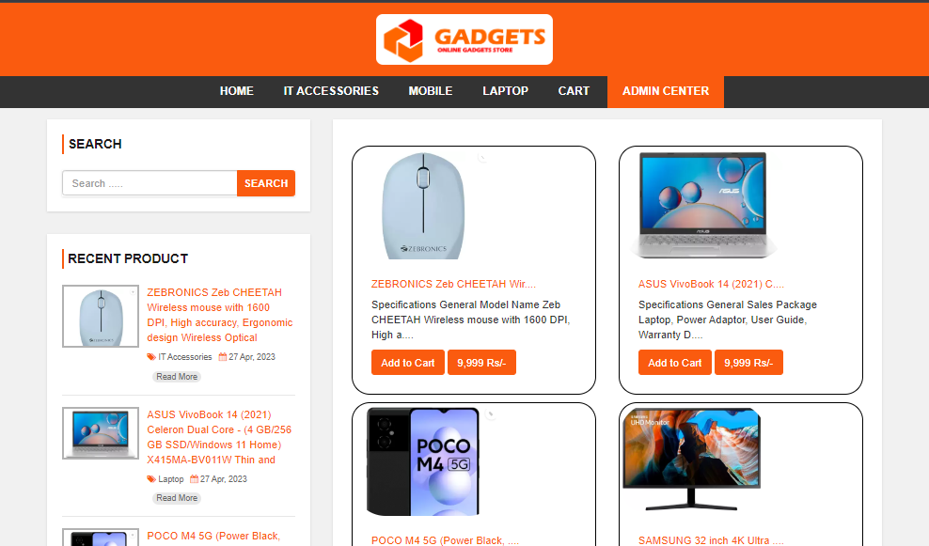
28-05-2024 06:15AM
HOME PAGE (PART – II)

28-05-2024 06:15AM
HOME PAGE (PART – III)
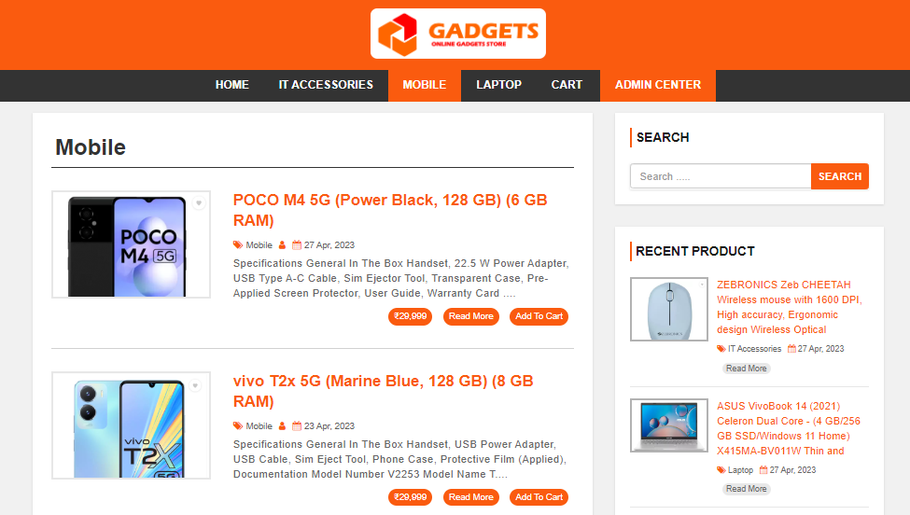
28-05-2024 06:15AM
HOME PAGE (PART – IV)
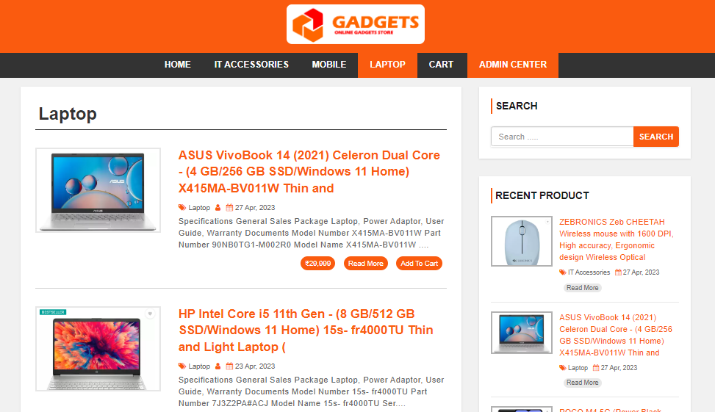
28-05-2024 06:15AM
HOME PAGE (PART – V)
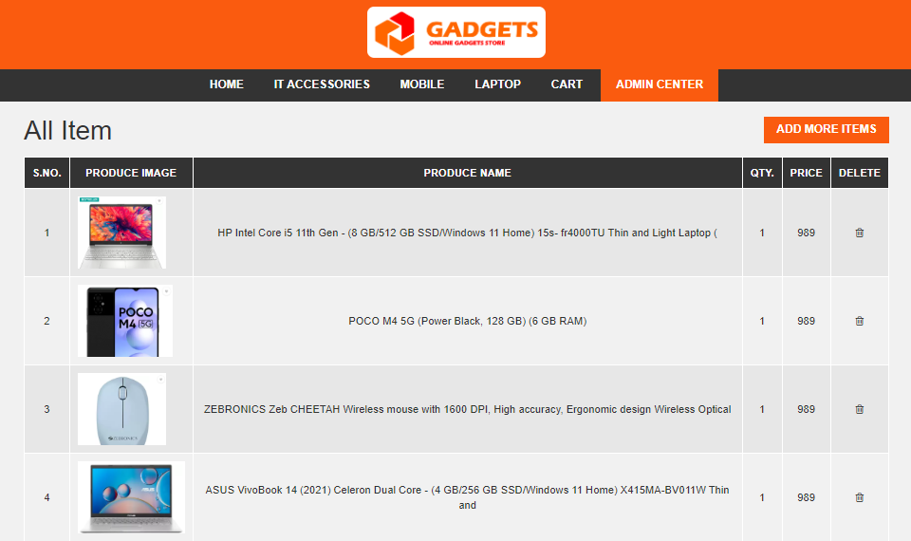
28-05-2024 06:15AM
Admin Page
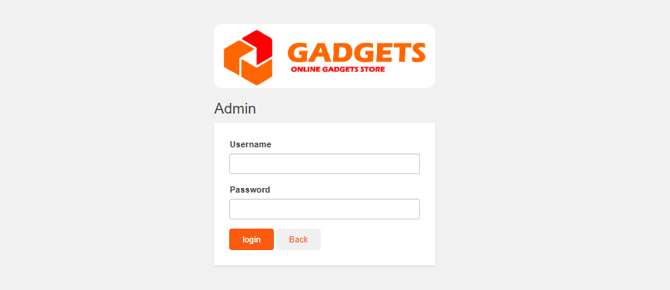
28-05-2024 06:15AM
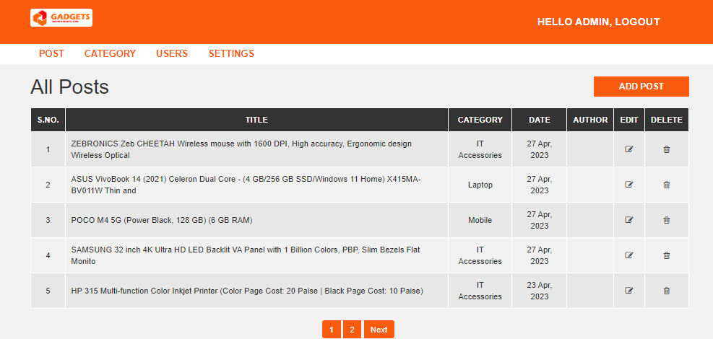
28-05-2024 06:17AM
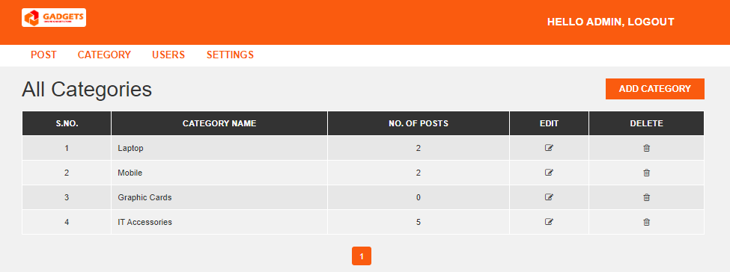
28-05-2024 06:17AM
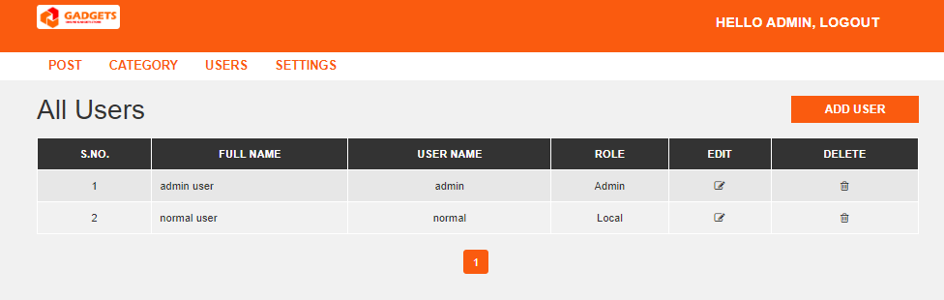
28-05-2024 06:15AM
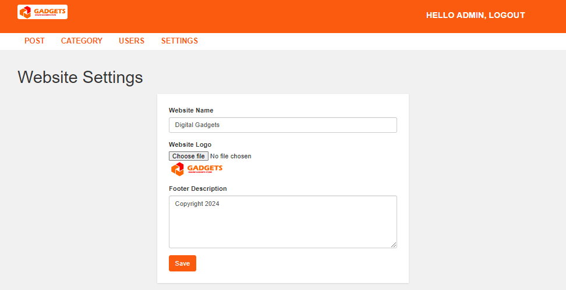
28-05-2024 06:15AM

BIBLIOGRAPHY

- Flipkart E-commerce
- Amazon E-commerce
- Font awesome
- Bootstrap

